**ENR 161 Fall 2017 Chapter 9 Homework**

Name _________________________________________________ Grade ______________

Step 1:

Watch the Video Entitled, **Excel Ch09 HW F16**, this video is stored on the M drive at MCC or on youtube.com.

Step 2:

Complete the questions and problems below.

1. What is a circular reference in Excel? What must be done to evaluate a cell with a circular reference?

2. What two items should be created before using Goal Seek or Solver to find the roots of a function?

3. Why were constraints needed when finding the relative minimum and maximum in the Min-Max worksheet?

4. How were the optimal fit values of coefficients A, B, and C found in the Vapor worksheet?

5. If a graph of YPredicted vs YMeasured is created what will the slope and y-intercept be equal to if YPredicted fits YMeasured perfectly?

**Grade for Questions (0-10)** ______________________

**Problem Stamp or Grade**

**Pages 369 to 373, Direct Worksheet** ______________________

1. Use the operations presented in Figures 9.11 to 9.22 to create the Direct worksheet.

2. Format your sheet has shown below. Use the descriptive cell names and formulas as shown.

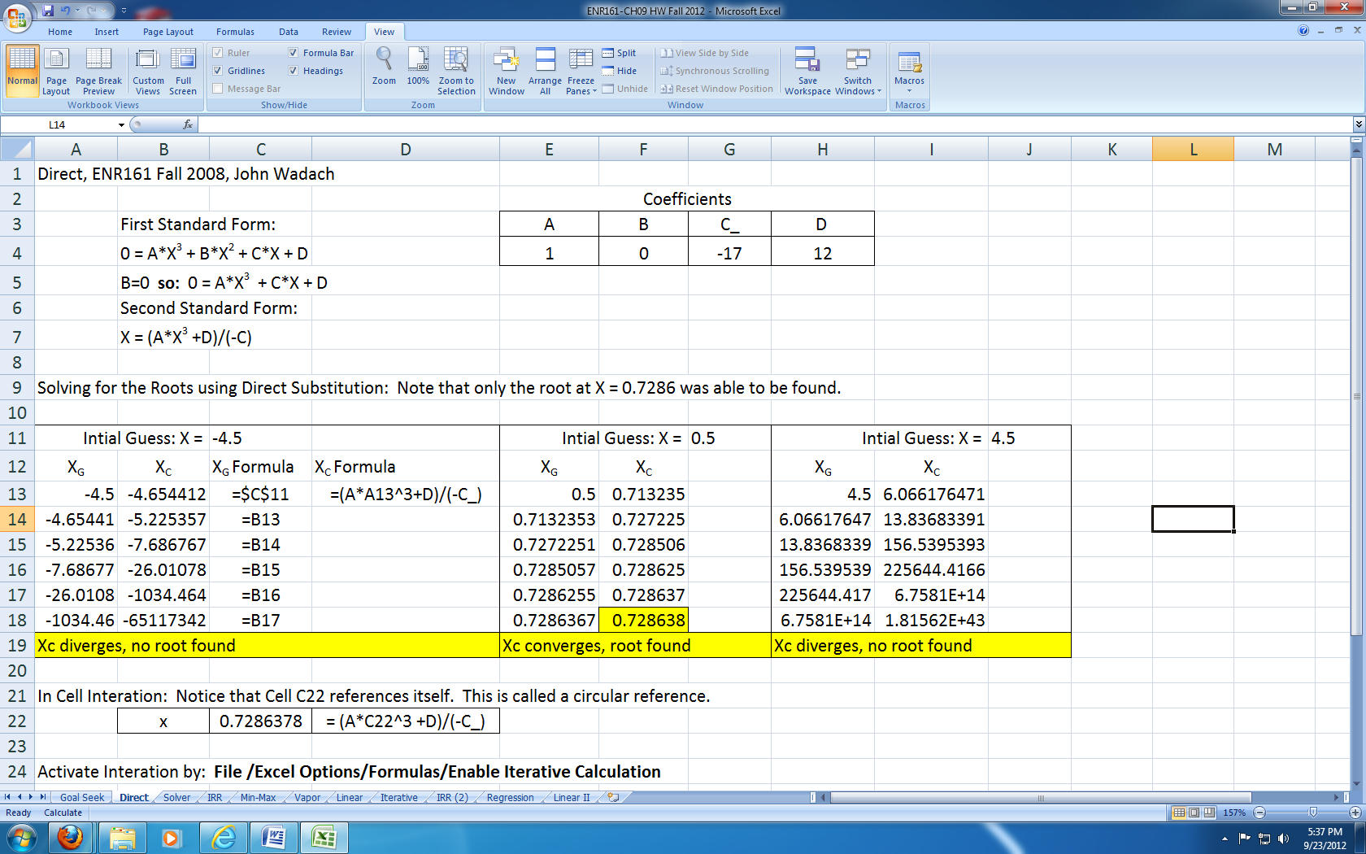 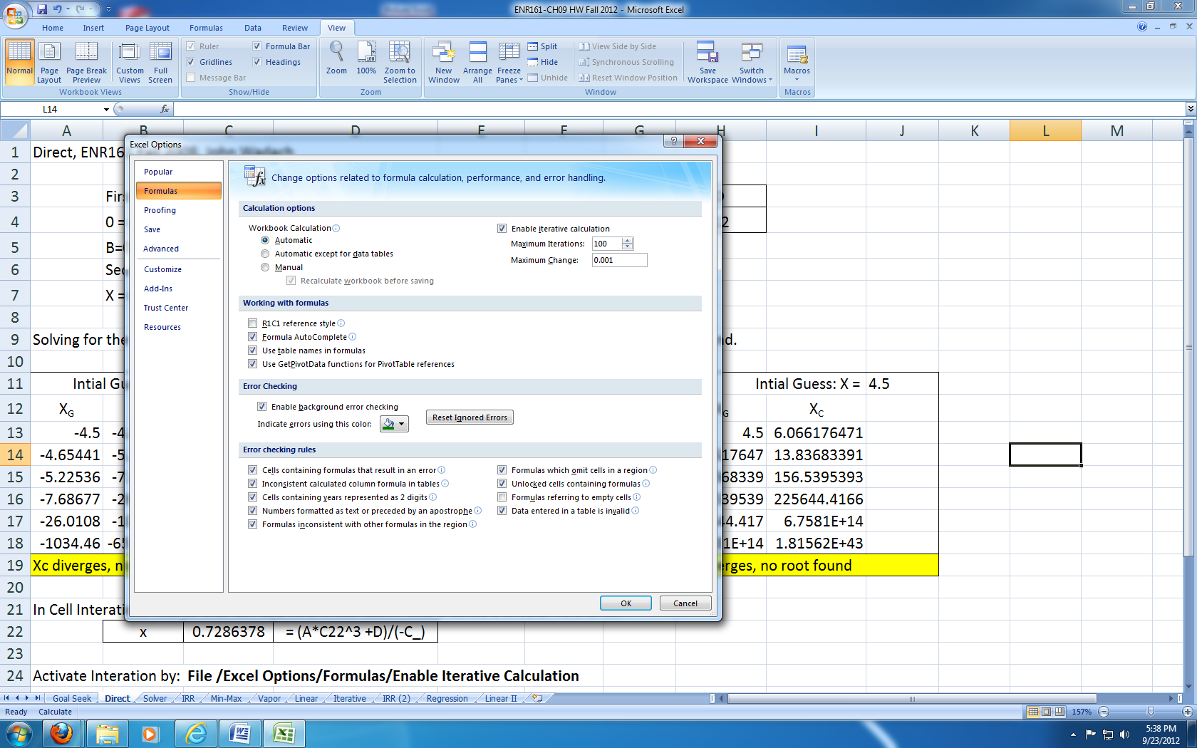

**Pages 374-375, Goal Seek Worksheet** ______________________

1. Use the operations presented in Figures 9.23 to 9.27 to create the Goal Seek worksheet.

2. Format your sheet has shown on the following page. Use the descriptive cell names and formulas as shown.

3. Prior to using Goal Seek, set the **Goal Seek Solution for X** column values equal to the **Initial Guess for X Values** column.

4. Apply Goal Seek **three times** in order to find all three roots.

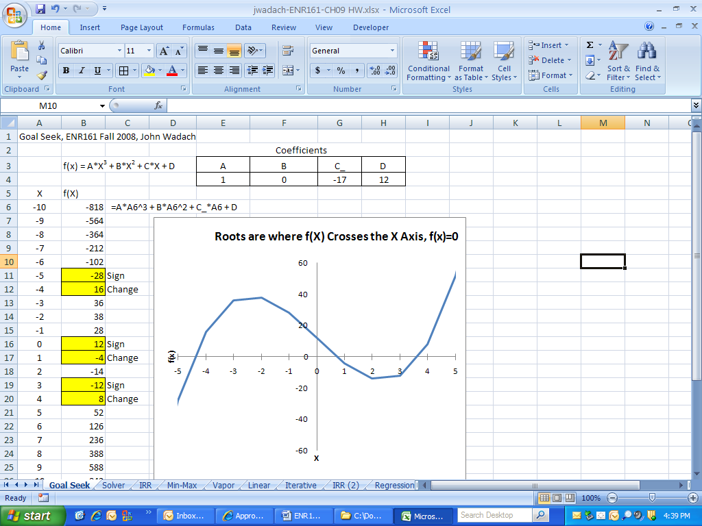 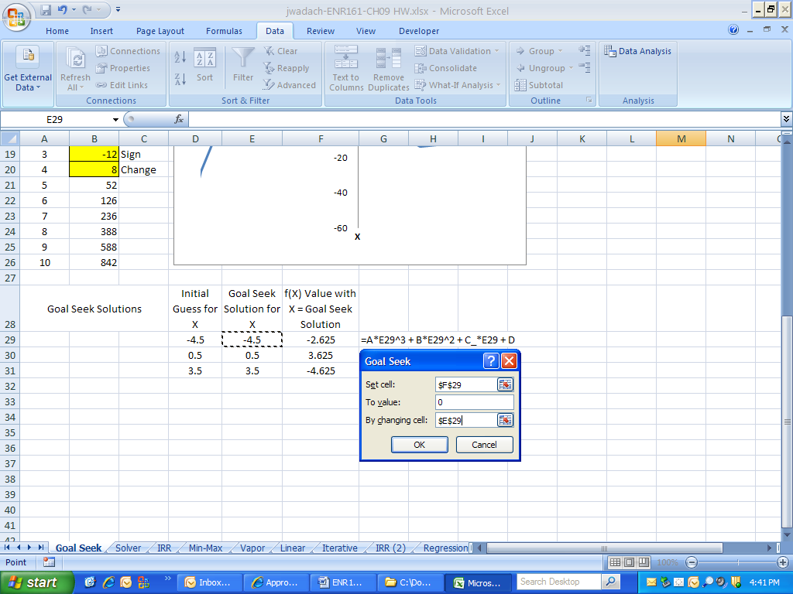

**Pages 377 to 380, Solver Worksheet** ______________________

1. Copy the Goal Seek worksheet and rename it Solver.

2. Use the operations presented in Figures 9.31 to 9.36 to create the Solver worksheet.

3. Format your sheet has shown below. Use the descriptive cell names and formulas as shown.

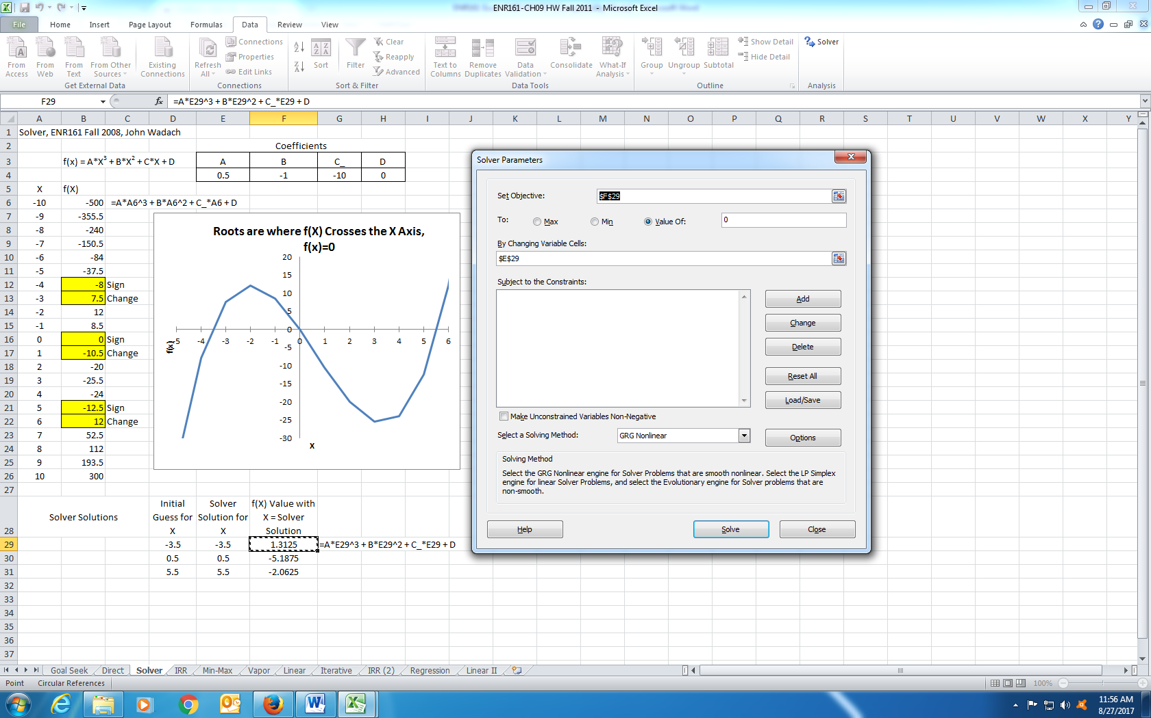

**Pages 384 to 388, Min-Max Worksheet** ______________________

1. Copy the Solver worksheet and rename it Min-Max.

2. Use the operations presented in Figures 9.43 to 9.55 to create the Min-Max worksheet.

3. Format your sheet has shown below. Use the descriptive cell names and formulas as shown.

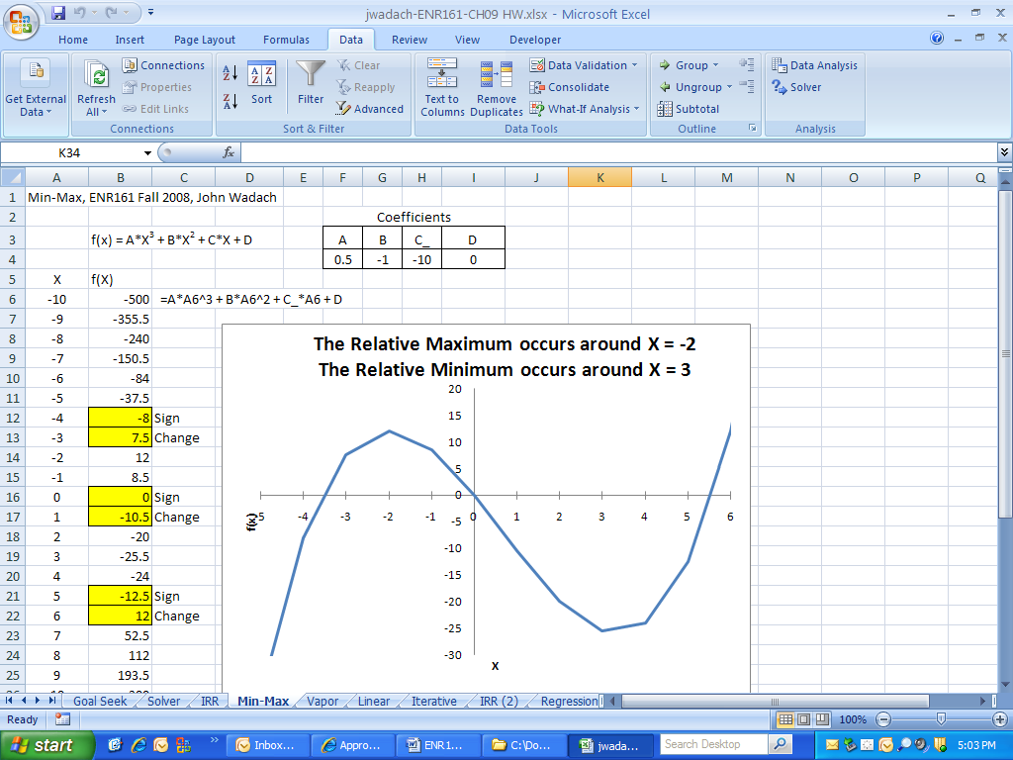 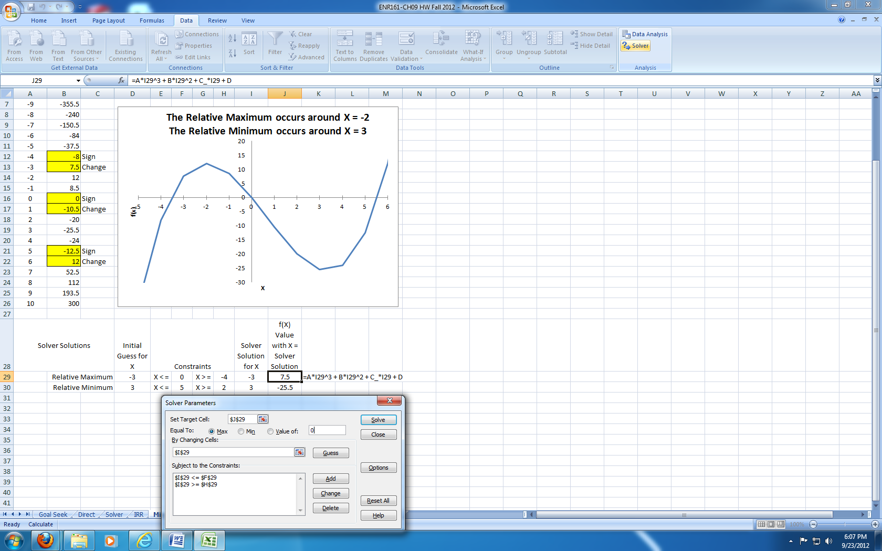

**Pages 389 to 396, Vapor Worksheet** ______________________

1. Copy the **Vapor Pressure** **Data** file into your worksheet. The data is located at **M:/Courses/ENR/ENR 161/Excel HW Data Files.**

2. Use the operations presented in Figures 9.56 to 9.69 to create the Vapor worksheet.

3. Format your sheet has shown below. Use the descriptive cell names and formulas as shown.

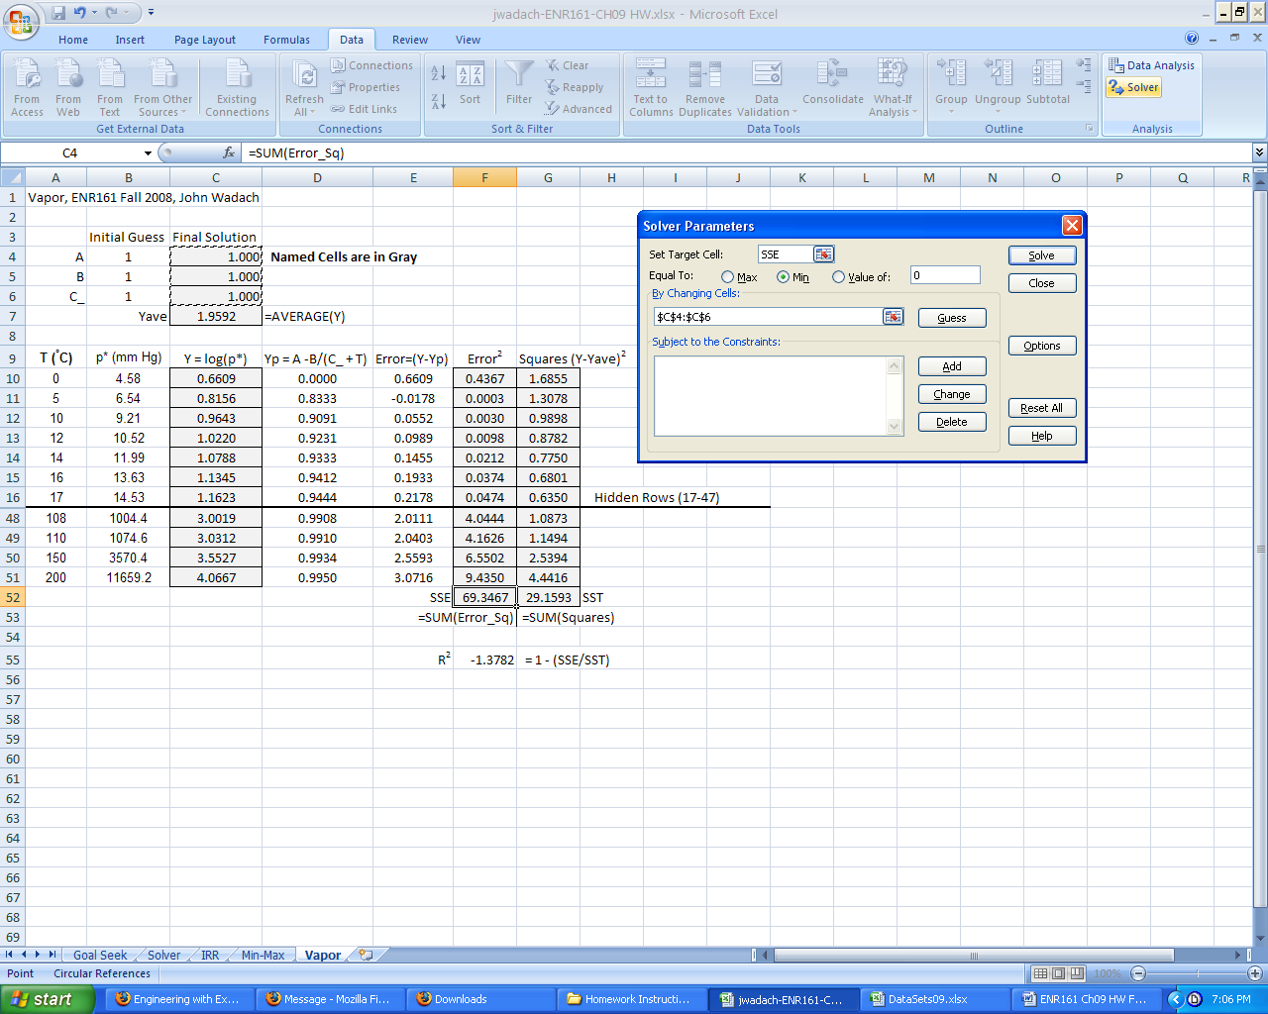

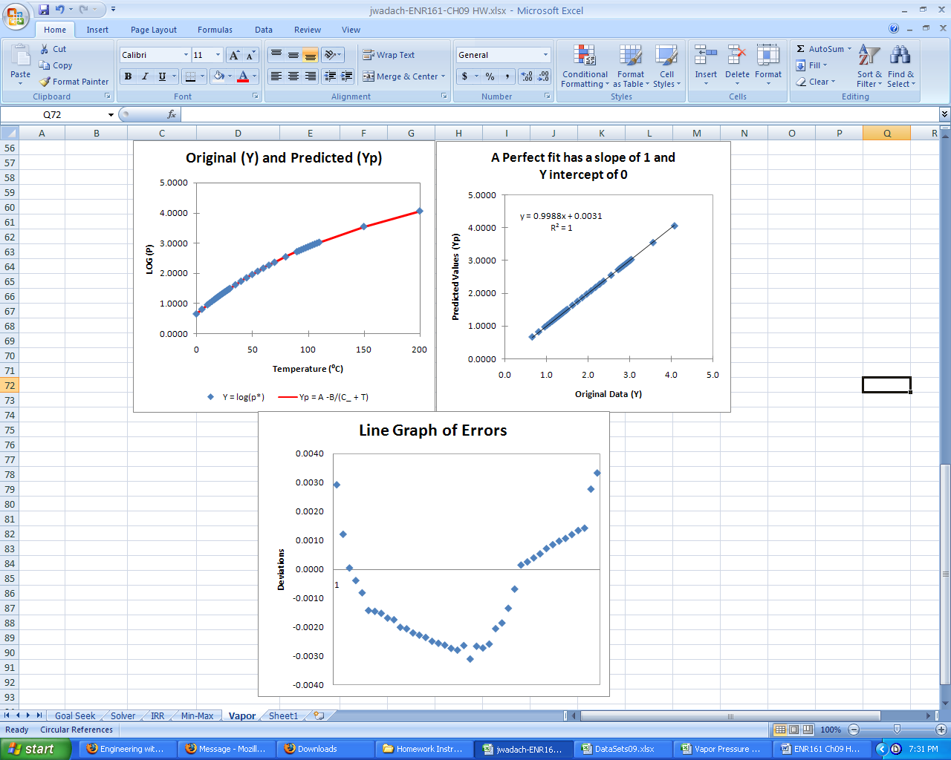

**Pages 400 to 405, Linear Worksheet** ______________________

1. Use the operations presented in Figures 9.76 to 9.84 to create the Linear worksheet.

3. Format your sheet has shown below. Use the descriptive cell names and formulas as shown.

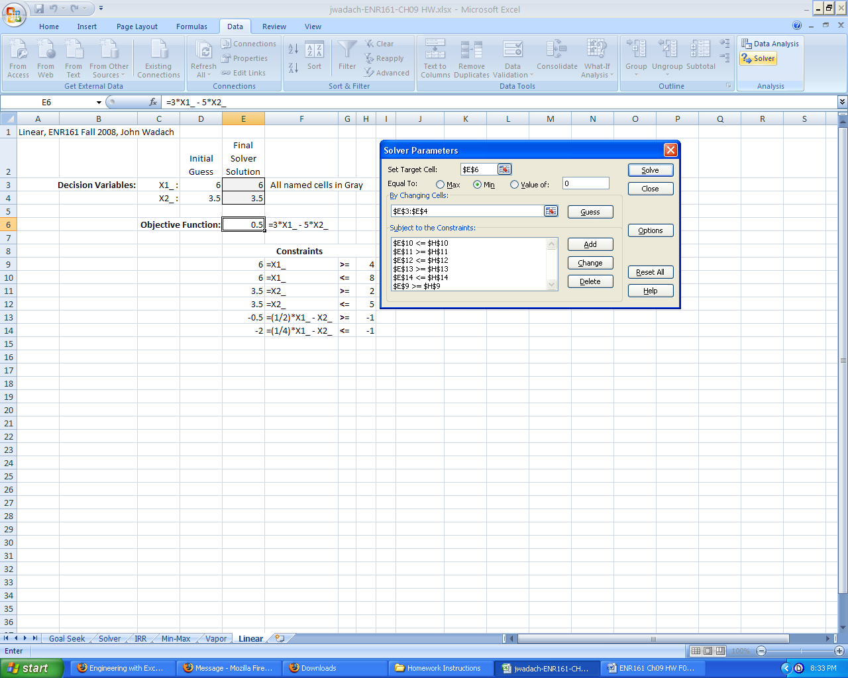

**Pages 414-415, Problem 9.1b, Iterative Worksheet**

1. Complete problem 9.1 part (b). ______________________

2. Format your sheet similar to the Solver worksheet and make sure that your graph clearly shows where the function crosses the X axis. Note that a third order polynomial equation may have either one or three real roots. **State the root(s) to 3 decimal places.**

**Pages 417-419, Problem 9.8, Regression Worksheet** ______________________

1. Copy the **Problem 9.8** data file into your worksheet. The data is located at **M:/Courses/ENR/ENR 161/ENR161 Data Files**.

2. Complete problem 9.8.

3. Format your sheet similar to the Vapor worksheet but you need to create only the graph that shows Y and Yp versus X. Use markers for the Y values and a line for the Yp values. Select marker and line formats that clearly show each.

**Page 419, Problem 9.9, Linear II Worksheet** ______________________

1. Complete maximization of 12X1+21X2+7X3+15X4 of problem 9.9.

2. Format your sheet similar to the Linear worksheet.

3. **Do not complete the food table part of this problem.**

Notes